HALL CHIROPRACTIC CENTER____
HEAD:
Headache
Sinus (allergy)
Entire head
Back of head
Forehead
Temples
Migraine
Head feels heavy
Loss of memory
Light-headedness
Fainting
Light bothers eyes
Blurred / Double vision
Loss of vision
Loss of taste
Loss of balance dizziness
Loss of hearing
Pain in ears
Ringing / buzzing in ears
NECK:
Pain in neck
Neck pain with movement:
Forward
Backward
Turn to left
Turn to right
Bend to left
Bend to right
Pinched nerve in neck
Neck feels out of place
Muscle spasms in neck
Grinding sounds in neck
Popping sounds in neck
Arthritis in neck
SHOULDERS:
Pain in shoulder ( R – L )
Pain across shoulders
Can’t raise arm ( R – L )
Above shoulder level
Over head
Pinched nerve in shoulder ( R – L )
ARMS & HANDS:
Pain in upper arm ( R – L )
Pain in elbow ( R – L )
Tennis elbow ( R – L )
Carpal Tunnel ( R – L )
Pain in forearm ( R – L )
Pain in hand ( R – L )
Pain in fingers ( R – L )
Pins & needles in arm ( R – L )
Pins & needles in fingers ( R – L )
1171 MARKET STREET _____ FOR
Numbness in arms ( R – L )
Numbness in fingers ( R – L )
Fingers go to sleep ( R – L )
Hand feels cold ( R – L )
Swollen joints in fingers ( R – L )
Arthritis in fingers ( R – L )
Loss of grip strength ( R – L )
MID-BACK:
Mid back pain
Pain between shoulder blades
Sharp stabbing pain
Dull ache
Pain from front to back
Pain in kidney area
CHEST:
Chest pain
Shortness of breath
Pain around ribs
ABDOMEN:
Nervous stomach
Foods can’t eat ___________
________________________
Nausea
Gas
Constipation
Diarrhea
Hemorrhoids
LOW BACK:
Low back pain
Upper lumbar pain
Lower lumbar pain
Sacroiliac pain
Slipped disc
Herniated disc
Muscle spasm
Arthritis
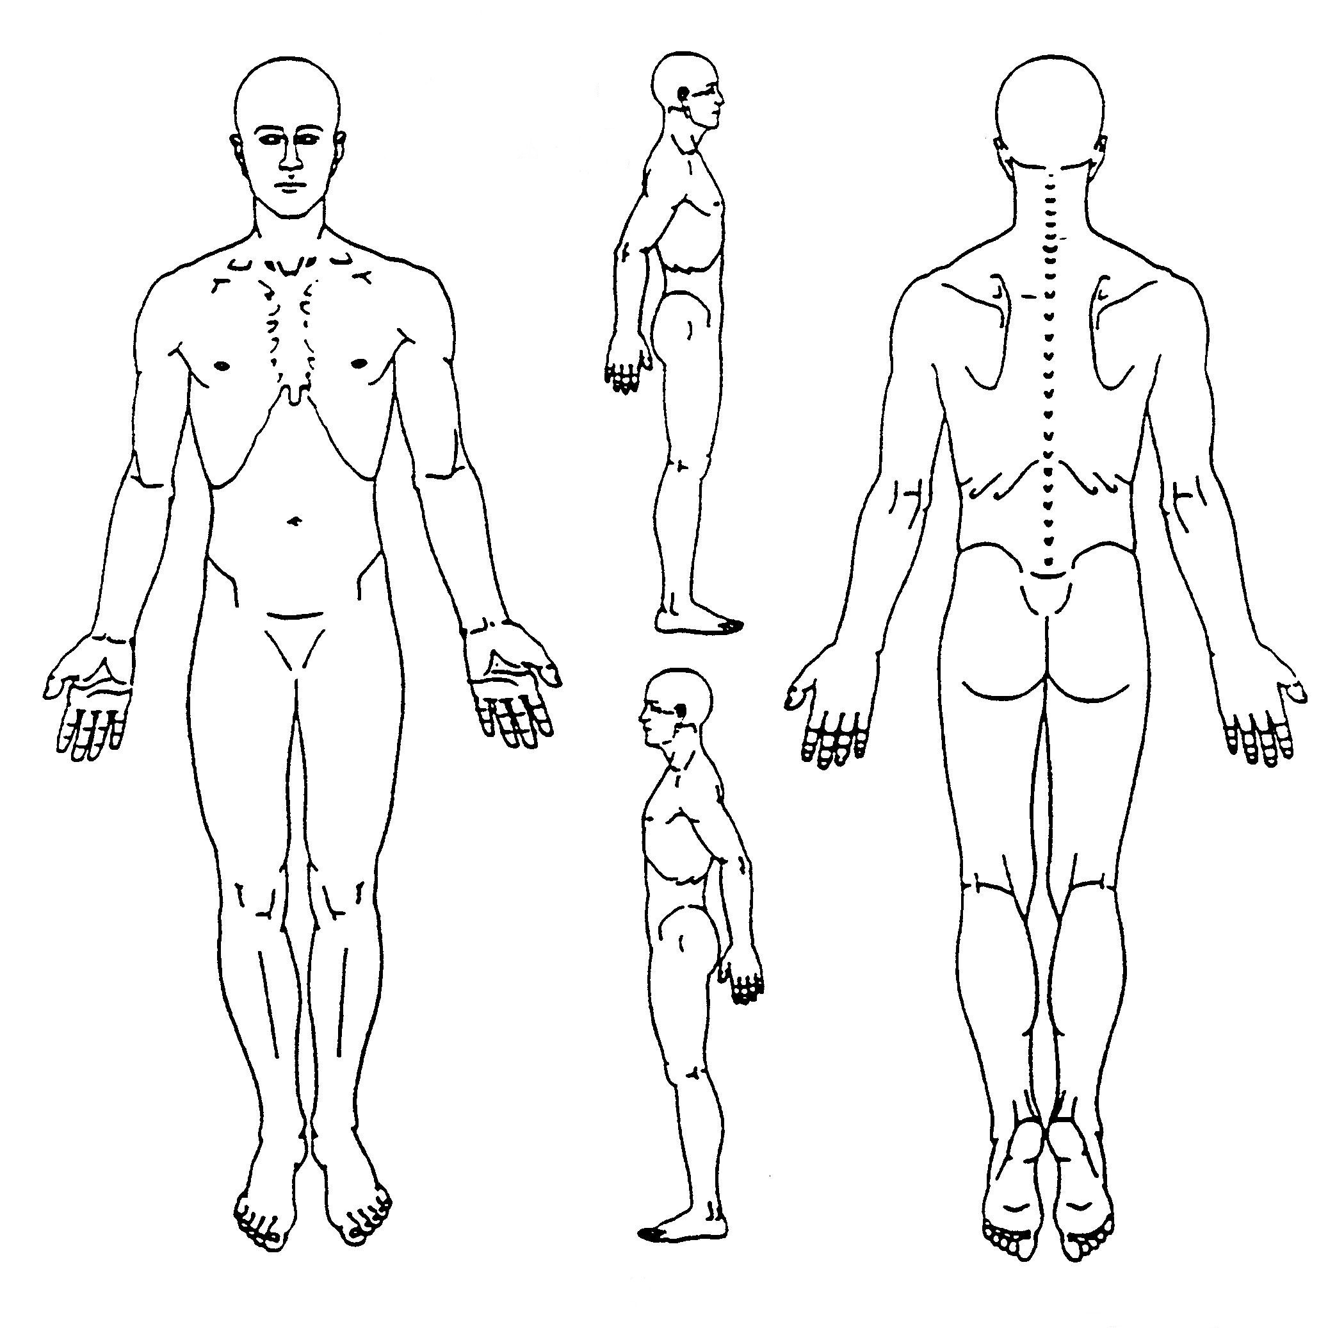
T MILL, SC 29708__ (803)412.2240
PLEASE CIRCLE AREAS OF SYMPTOMS
Low back pain worse when:
Working
Walking
Lifting
Getting up / down
Standing
Sitting
Bending
Coughing
Lying down
Sleeping
Pain relieves when ______________
HIPS, LEGS, FEET
Pain in buttock ( R – L )
Pain in hip joint ( R - L )
Pain down leg ( R – L )
Knee pain ( R – L )
Foot pain ( R – L )
Leg cramps
Pins & needles in leg ( R – L )
Numbness in leg ( R – L )
Pins & needles foot/toes ( R – L )
Numbness in foot/toes ( R – L )
Feet feel cold
Swollen ankle / foot ( R – L )
GENERAL:
Nervousness
Irritable
Depressed
Fatigue
Sleeplessness
Sleep ______ hours
Weight gain
Weight loss
Diabetes
Fibromyalgia

